Flight Database

Code –

create database airline_flight_database_5;

use airline_flight_database_5;

CREATE TABLE FLIGHTS(

FL_ID INT,FROM_PLACE VARCHAR(20),

TO_PLACE VARCHAR(20),

DISTANCE INT,

DEPARTS TIME,

ARRIVES TIME,

PRICE INT,

PRIMARY KEY(FL_ID));

CREATE TABLE AIRCRAFT(

A_ID INT,

A_NAME VARCHAR(10),

CRUISING_RANGE INT,

PRIMARY KEY(A_ID));

CREATE TABLE EMPLOYEE(

E_ID INT,

E_NAME VARCHAR(10),

SALARY INT,

PRIMARY KEY(E_ID));

CREATE TABLE CERTIFIED(

E_ID INT,

A_ID INT,

FOREIGN KEY(E_ID) REFERENCES EMPLOYEE(E_ID),

FOREIGN KEY(A_ID) REFERENCES AIRCRAFT(A_ID));

INSERT INTO FLIGHTS VALUES(111,'BENGALURU','FRANKFURT',1000,'09:30','16:00',10000);

INSERT INTO FLIGHTS VALUES(222,'MANDISON','BENGALURU',1020,'01:30','7:00',9000);

INSERT INTO FLIGHTS VALUES(333,'BENGALURU','FRANKFURT',1000,'01:40','12:00',9500);

INSERT INTO FLIGHTS VALUES(555,'NEW DELHI','NEW YORK',5000,'13:30','17:00',15000);

INSERT INTO FLIGHTS VALUES(444,'BENGALURU','NEW DELHI',550,'08:00','13:00',5000);

INSERT INTO FLIGHTS VALUES(666,'MANDISION','NEW YORK',12000,'16:30','19:00',20000);

SELECT * FROM FLIGHTS;

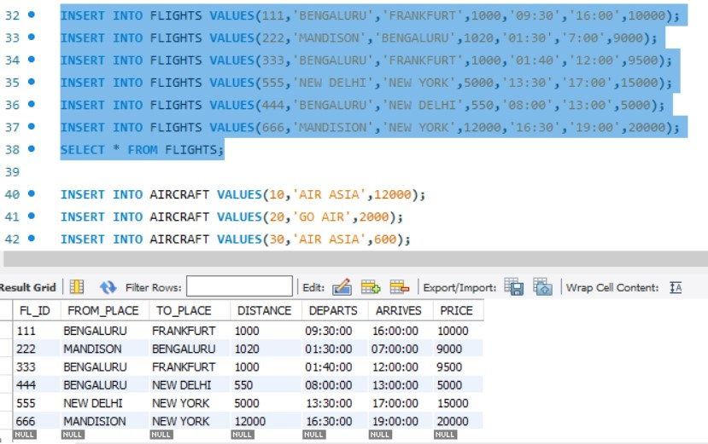

INSERT INTO AIRCRAFT VALUES(10,'AIR ASIA',12000);

INSERT INTO AIRCRAFT VALUES(20,'GO AIR',2000);

INSERT INTO AIRCRAFT VALUES(30,'AIR ASIA',600);

INSERT INTO AIRCRAFT VALUES(40,'INDIGO',5000);

INSERT INTO AIRCRAFT VALUES(50,'SPICE JET',900);

INSERT INTO AIRCRAFT VALUES(60,'SPICE JET',12500);

SELECT * FROM AIRCRAFT;

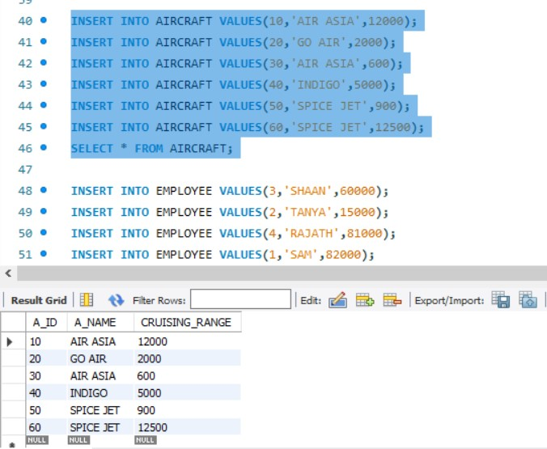

INSERT INTO EMPLOYEE VALUES(3,'SHAAN',60000);

INSERT INTO EMPLOYEE VALUES(2,'TANYA',15000);

INSERT INTO EMPLOYEE VALUES(4,'RAJATH',81000);

INSERT INTO EMPLOYEE VALUES(1,'SAM',82000);

INSERT INTO EMPLOYEE VALUES(6,'AYMAN',70000);

INSERT INTO EMPLOYEE VALUES(5,'SAAKSHI',9000);

SELECT * FROM EMPLOYEE;

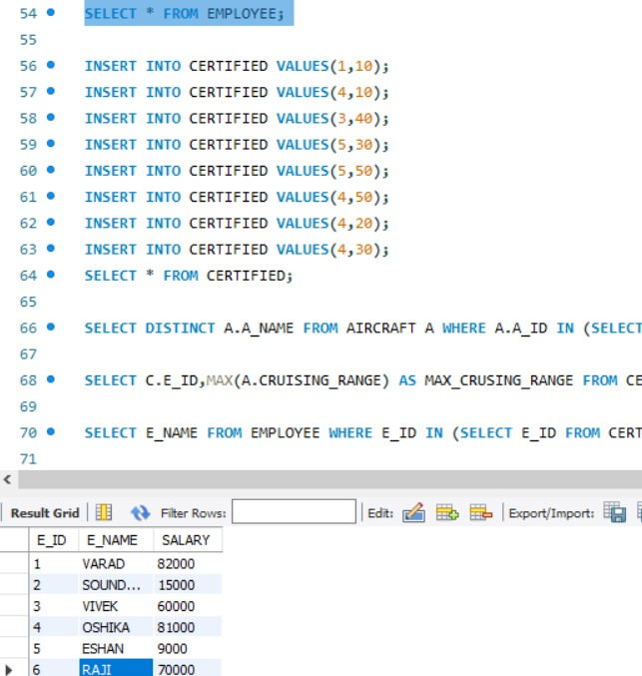

INSERT INTO CERTIFIED VALUES(1,10);

INSERT INTO CERTIFIED VALUES(4,10);

INSERT INTO CERTIFIED VALUES(3,40);

INSERT INTO CERTIFIED VALUES(5,30);

INSERT INTO CERTIFIED VALUES(5,50);

INSERT INTO CERTIFIED VALUES(4,50);

INSERT INTO CERTIFIED VALUES(4,20);

INSERT INTO CERTIFIED VALUES(4,30);

SELECT * FROM CERTIFIED;

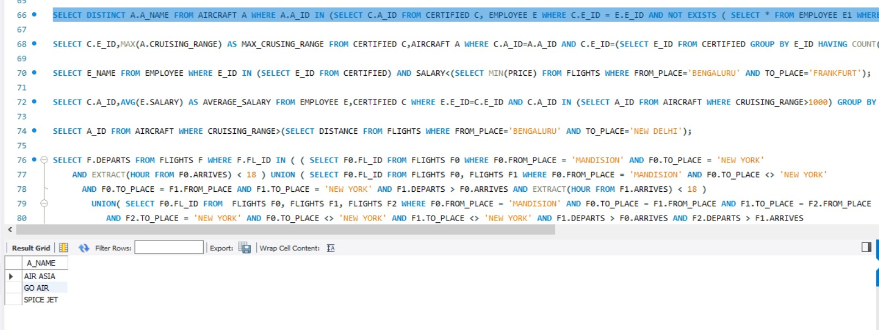

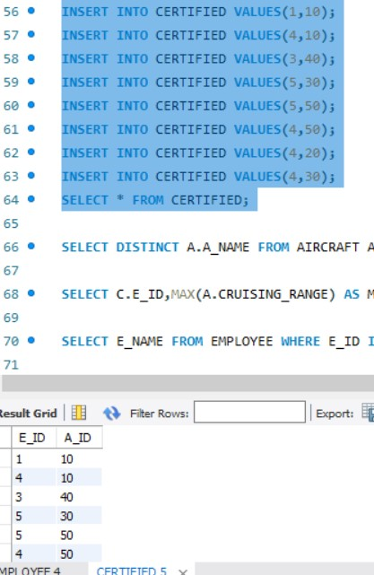

SELECT DISTINCT A.A_NAME FROM AIRCRAFT A WHERE A.A_ID IN (SELECT C.A_ID FROM CERTIFIED C, EMPLOYEE E WHERE C.E_ID = E.E_ID AND NOT EXISTS ( SELECT * FROM EMPLOYEE E1 WHERE E1.E_ID = E.E_ID AND E1.SALARY <80000 ));

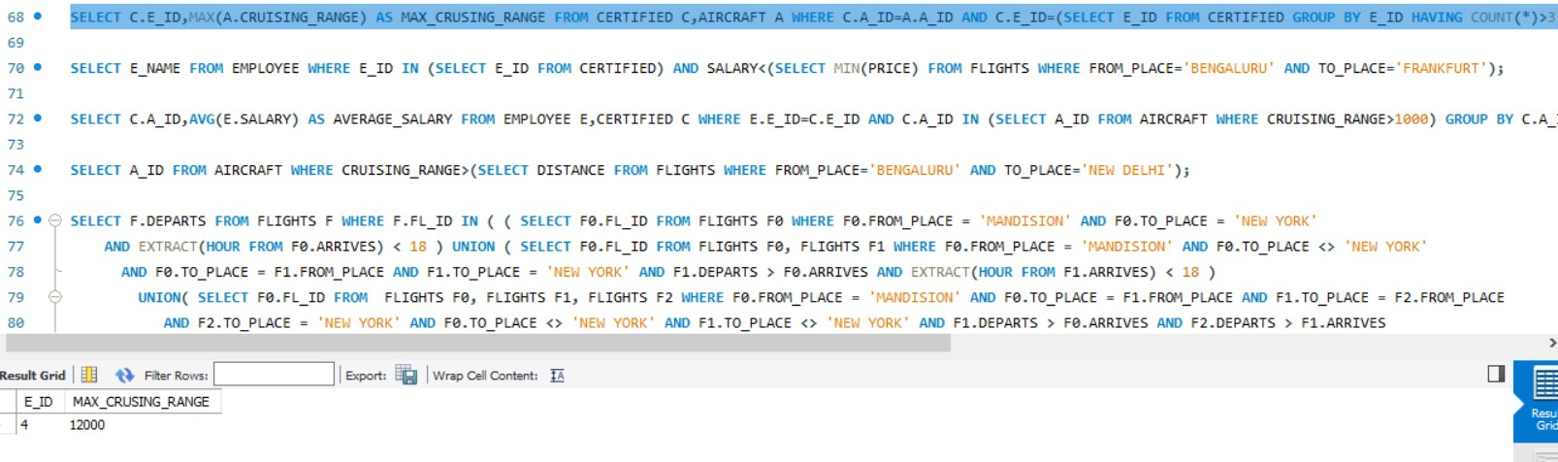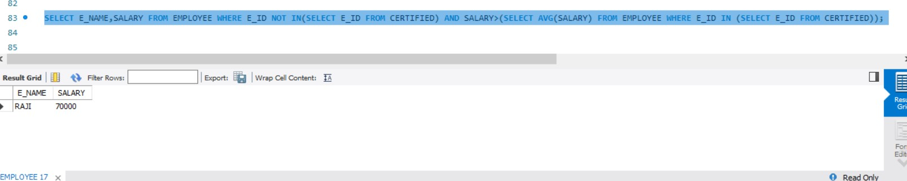

SELECT C.E_ID,MAX(A.CRUISING_RANGE) AS MAX_CRUSING_RANGE FROM CERTIFIED C,AIRCRAFT A WHERE C.A_ID=A.A_ID AND C.E_ID=(SELECT E_ID FROM CERTIFIED GROUP BY E_ID HAVING COUNT(*)>3);



SELECT E_NAME FROM EMPLOYEE WHERE E_ID IN (SELECT E_ID FROM CERTIFIED) AND SALARY<(SELECT MIN(PRICE) FROM FLIGHTS WHERE FROM_PLACE='BENGALURU' AND TO_PLACE='FRANKFURT');

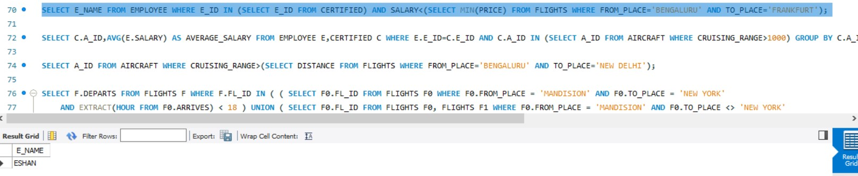

SELECT C.A_ID,AVG(E.SALARY) AS AVERAGE_SALARY FROM EMPLOYEE E,CERTIFIED C WHERE E.E_ID=C.E_ID AND C.A_ID IN (SELECT A_ID FROM AIRCRAFT WHERE CRUISING_RANGE>1000) GROUP BY C.A_ID;

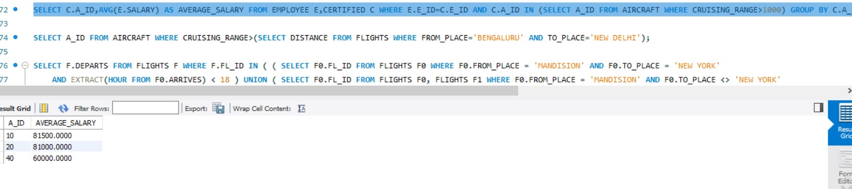

SELECT A_ID FROM AIRCRAFT WHERE CRUISING_RANGE>(SELECT DISTANCE FROM FLIGHTS WHERE FROM_PLACE='BENGALURU' AND TO_PLACE='NEW DELHI');

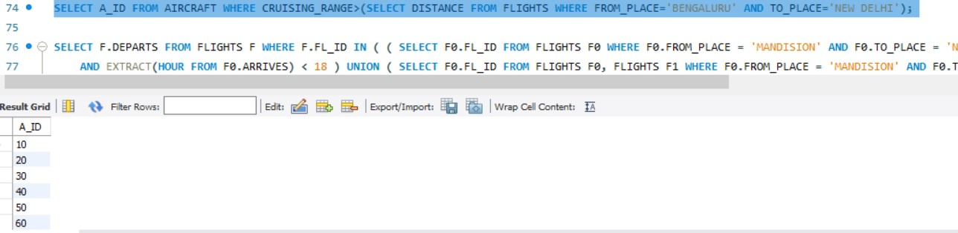

SELECT F.DEPARTS FROM FLIGHTS F WHERE F.FL_ID IN ( ( SELECT F0.FL_ID FROM FLIGHTS F0 WHERE F0.FROM_PLACE = 'MANDISION' AND F0.TO_PLACE = 'NEW YORK'

AND EXTRACT(HOUR FROM F0.ARRIVES) < 18 ) UNION ( SELECT F0.FL_ID FROM FLIGHTS F0, FLIGHTS F1 WHERE F0.FROM_PLACE = 'MANDISION' AND F0.TO_PLACE <> 'NEW YORK'

AND F0.TO_PLACE = F1.FROM_PLACE AND F1.TO_PLACE = 'NEW YORK' AND F1.DEPARTS > F0.ARRIVES AND EXTRACT(HOUR FROM F1.ARRIVES) < 18 )

UNION( SELECT F0.FL_ID FROM FLIGHTS F0, FLIGHTS F1, FLIGHTS F2 WHERE F0.FROM_PLACE = 'MANDISION' AND F0.TO_PLACE = F1.FROM_PLACE AND F1.TO_PLACE = F2.FROM_PLACE

AND F2.TO_PLACE = 'NEW YORK' AND F0.TO_PLACE <> 'NEW YORK' AND F1.TO_PLACE <> 'NEW YORK' AND F1.DEPARTS > F0.ARRIVES AND F2.DEPARTS > F1.ARRIVES

AND EXTRACT(HOUR FROM F2.ARRIVES) < 18 ));



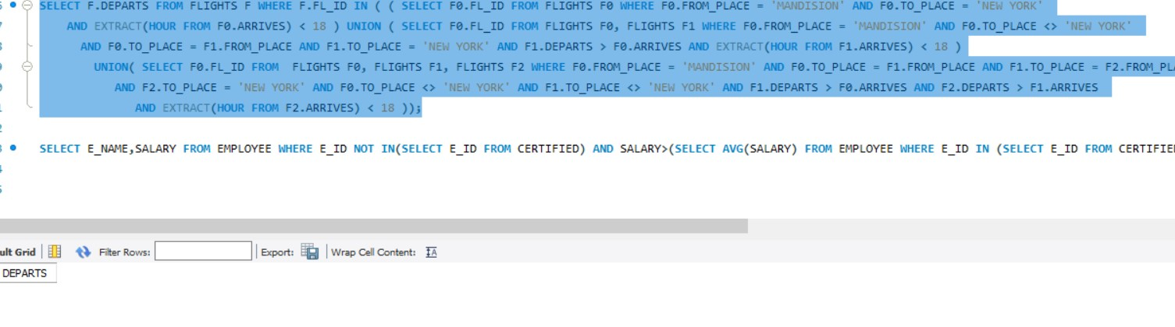

SELECT E_NAME,SALARY FROM EMPLOYEE WHERE E_ID NOT IN(SELECT E_ID FROM CERTIFIED) AND SALARY>(SELECT AVG(SALARY) FROM EMPLOYEE WHERE E_ID IN (SELECT E_ID FROM CERTIFIED));

